8.27

China hilo made money.

Open dev didn’t.

After even number of orders, trade at conservative level.

Futopen – didn’t work -> prolong the wait time from 45 sec to 60 sec.

China hilo today modifcations:

1. Only go on to next order if previous order filled
2. After even orders, trade conservative to open
3. Potentially after open (>9:40), trade at freshPrice, when markets are more directional.

During the weekend:

1. No more intraday shorts (these lose money), use percMA to cut delta overnight

Problems:

When to trade conservatively.

1. Before/after 9:40?
2. When prev orders are even?
3. There should be 1 aggressive trader and 1 conservative trader.
4. Open trader should be aggressive at opening and **passive later**. Open traders are only expected to trade a lot during the open. Later it should not trade if markets are still at the opening level in later stages. (lose some slipping and focus on beginning). After the beginning, should only trade near the open line.
5. Hilo trader should be passive at opening and aggressive later(not necessarily). (let open trader take the leader role at the open, and hilo trader can trade at low/highs throughout the day at aggressive level(guarantee fill later in the day when more directional)).

下午: 市场很猛. 波动很大, 很多票都长了3/4%.

波动性高的时候, chinaHiLo和openDev的好处就显现出来了.

期货仓位现在太不灵活.

之后要根据Hilo情况大幅度调整仓位.

先完全calibrate所有策略类型.

好用了以后逐渐加仓.

这段时间做了很多fut trader的迭代. 这个是早晚都要做的.

Hilo和deviation这个早就应该做, 市场波动剧烈的时候, 这种策略long vol是很管用的.

做intraday short和long基本都会输钱.

When you trade with bigger size, fill becomes an issue.

Opening trade needs to be conservative, and closing trade needs to be aggressive.

When closing trade happens, it means open trade is wrong.

Today, chinahilo found direction at 9:32:18.

Opendev didn’t get filled at 9:37 (openDev wasn’t aggressive enough)

Aggressiveness of OpenDev vs. Chinahilo

Open dev:

1. Opening: index will beat around the open, so need to be aggressive to guarantee fills
2. Later, index is supposed to have departed from opening already. If it is still near the open, that means the day is not good for this, so you need to trade conservatively.
3. So overall, aggressive -> conservative.

ChinaHilo

1. Opening: open dev is trading aggressively to gain advantage, chinahilo doesn't need to do the same
2. Chinahilo trades less frequently but with bigger size, level is more important. Either get the right level or not trade at all. Even trades will be opening trades and they will be conservative.
3. Later in the day, there will be less hilos, but once a hilo is reached, it is significantly, so we want to guarantee fills at this time. So we trade aggressively later during the day.

The key

1. When signals are infrequent but important, trade aggressively because fills are more important than level (like HILO during later day)
2. When signals are frequent and a lot of noise is involved and very volatile, trade passively because it is easier to get fills and there will be more mistakes if aggressive. (like HILO at the open).
3. When signals are frequent but fills are important, also trade aggressively (like open_dev during the open, missing a trade will

HILO is mostly geared towards adjusting the hedge by big amounts when hilo happens. This one will have heavy positioning. Fills are important. Signals need to be less and more accurate. Escape opening signals as these are noise (use passive trading to screen opening noise).

OPENDEV is mostly geared towards quickly trading the open. During later parts of the day, this trader is not supposed to work aggressively. If there are opendev trades later in the day, that means there is no trend and the signals have no value, so later in the day, openDev should be reluctant to trade. However, at the open, open devs need fills as this needs to trade in the correct direction, so fills are important at the open but not later. Today there was one OPENDEV that was missed with heavy consequences.

From today’s experience:

1. Open dev becomes more aggressively at open to secure more fills to ensure correct direction. Aggressive with more urgency to fill -> conservative with bad signals(price level still at the open)/no urgency to fill.
2. Hilo there are less signals but important. Use these signals to change delta (need fills , very important). At the open, things are not clear and it is not smart to trade huge positions. So use conservative price levels at the open. Later in the day when there are less hits, use aggressive price levels. Conservative with messy signals/less urgency-> aggressive with better signals/more urgency to fill

8.28

Market is still very volatile, very suitable for hilo trading, not suitable for percentile trading.

Stock ptf moved by 3% ytd, annualized that is 48%.

Automate opening process even more: (Do this before breakfast)w

Pop up asking if auto, wait for 3 seconds, then do all tasks auto.

1. Load hib/load hib Y
2. Get index/ on IB HK
3. ChinaPosition: getCurrent, getOpen, Active Only, Refresh, click on autoupdate
4. Mon: refresh and compute

Opening trading:

1. Open dev got knocked out within 5 minutes. -> Signals too frequent, knocking out too fast -> not the day to trade.
2. Hilo traded 4 times. (+2), basically means that it is directionless .

**To think about:**

1. Size should be smaller as orderSize gets larger

One to two orders -> full size

Three to four orders, medium size

Five to six orders, small sizes

1. First tick trade made money – increase size on it
2. Sizing should depend on how far away this order is from the last. (implemented)

After close:

1. Intraday buy MA orders were well placed, during low parts of the curve
2. The last chinalo made money, selling at 11535, fut dropped to 11485 at one point. Some work is needed on HILO. Buy and sell needs to be same size. TimeSinceLastOrder need to regulate the next order’s size. 10:02 order needs to be emphasized .

8.29

Opening speed improvement

1. Dialog opens and becomes visible (window starts to block)
2. Timer starts
3. After 3 seconds, timer goes into action
4. Immediately after time goes into AE, kill the window, end the blocking of JD
5. Get user selection
6. Run long task (if needed)

Lunch time:

China hilo problem

1. Bought at the highs.
2. 买的level比较差. 应该加入open percentile. OP >50的话, 证明有下跌过程, 这个时候要少买. OP < 50 可以正常买.
3. OP < 50 的时候, 证明日中有上涨过程, 要谨慎卖.

HILO improvement:

1. When pmchy < -20, no selling on hilo, so max trades is one long. (shorting will lose money in expectation). But there is no requirement on long + pmchy>20, because there is no correlation.
2. No selling with pmch < -20 on all trade types.
3. Increase size on percentileMA and intradayMA on PM buy trades.

8.30

Implement weekday differentiated sizing strategy

Strategy improvement:

1. Add Thursday weakness
2. Add unconditional hedger.
3. Pmchy is not that accurate in capturing index.
4. Replace sh000001 pmchg as the official one. Don’t use the one for futures.
5. For for current day pmchy, also use that for the index.

8.31

Stocks everyweek cut 100k delta, then offshore it.

Want more assets offshore.

Liquidated chinese holdings, start to transfer money offshore. Over 2 years lost money in the market, whereas the rest of the world broke new highs. Structural problems with the market.

Start to channel money offshore.

Use futures to trade china, without long position, short position doesn’t need to be that big. 25% or 1mm can do the job. It’s more flexible. If you wanted to take a short position previously you need to short around -3mm of delta which is too big on one side.

Chinese market is shit in the long run, the earlier you get out the better off you are, use futures to take advantage of the volatility, that’s it. Don’t hold stocks for the long term.

Offshore about 100k per week. Aim at 4-5 months to totally offshore the assets.

1. 产业链低端, 没有处于产业链高端的公司
2. 受制于美国制裁, 贸易战
3. 好公司少, 靠白酒公司撑起来经济就是扯淡.
4. 好公司都是境外上市. (阿里巴巴, 小米)
5. 电器企业也没有什么技术含量, 像美的这种生产电风扇的公司怎么跟谷歌比
6. 中国股市有重大的结构性问题,不适合投资
7. 利用高波动率做期货交易, 整合资源用在最大的优势上.
8. 国内的市场被操纵, 政府完全割韭菜. 在这里面玩不明智.

Weekend analysis:

Fut:

Expired:

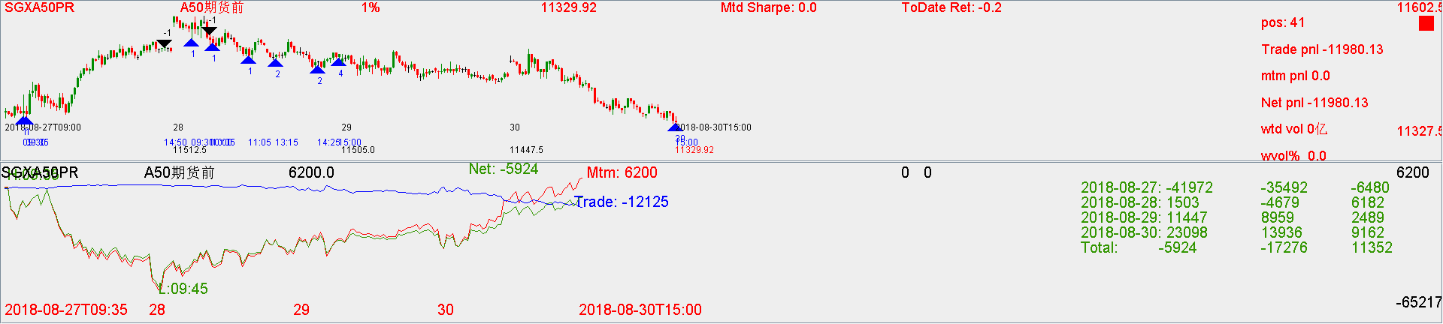

IntradayMA cost money.

Decommissioning:

Decommission intraMA.

Decommission firstTickMAProfittaker.

Decommission percentileMABuy.

Lower the weight of pmch.

Default wait time to 5 minutes (300 seconds to lower mishits)

Upgrading:

Use 5 minute to determine direction, 6 trades max.

No accumulator.

Current:

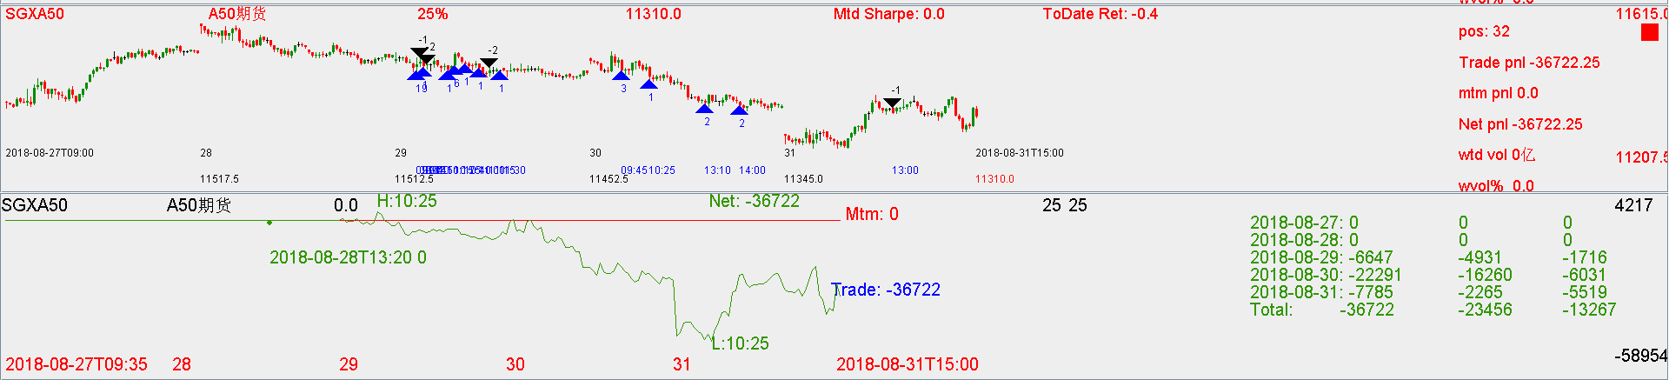

Recap:

Cash:

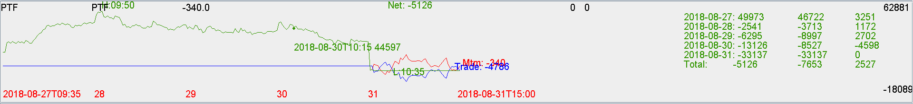

Friday liquidated ptf. Focus advantage on auto trading, not on buy and hold.